3.1-3.4 Mini Quiz: Reading & Interpreting Histograms (COMPLETE)

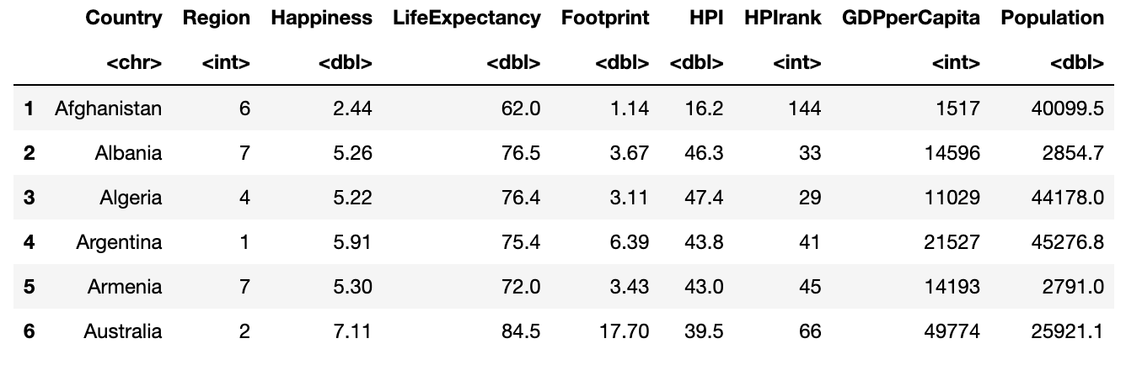
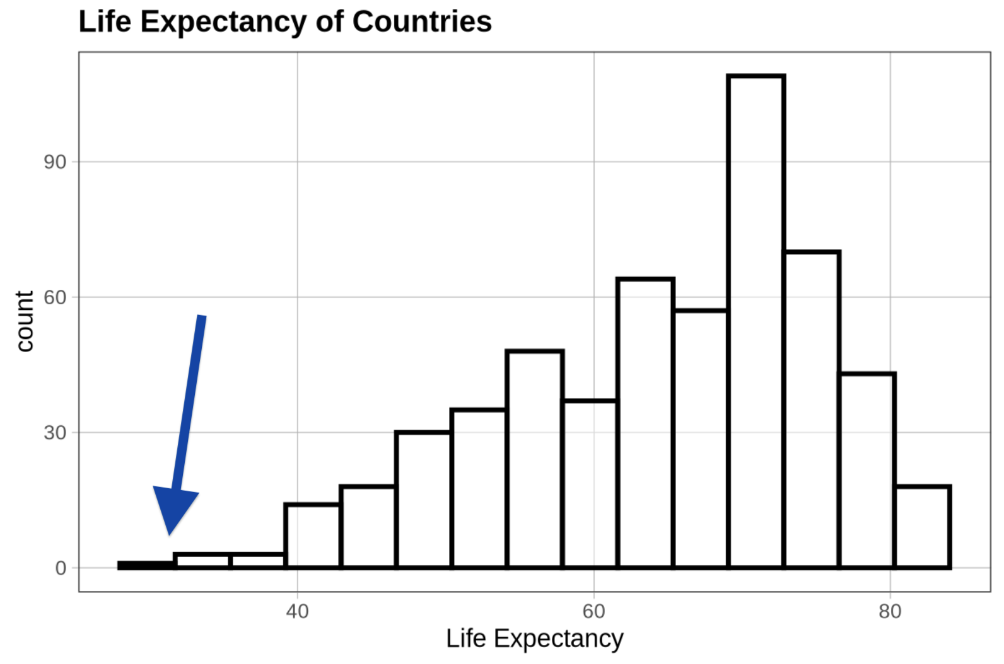
A student is learning how to read histograms and used a sample from the Gapminder data on life expectancy (in years) for countries around the world. They created a histogram to better understand the distribution and now need guidance interpreting different parts of the graph. Help describe some of its key features.

- What does the x-axis represent in this histogram?

It represents the life expectancy in years.

- What does the y-axis represent in this histogram?

It represents the number of countries with a particular life expectancy.

- What does the shortest bar on the histogram tell you?

It tells you that these are the countries with the lowest life expectancy, and that this is the life expectancy value with the fewest number of countries.

- What does the tallest bar on the histogram tell you?

It tells you that this is the life expectancy (about 70 years) with the highest number of countries.

- If we added a country with a mean life expectancy of 30 years to this data, where would it show up on the histogram? Use an arrow or circle to show where it belongs.

